PENTAHO ASSIGNMENT-1
NAME:PUGALMANI.K
REG NO:1P25CS013
CLASS:1ST MSC COMPUTER SCIENCE

- Find the total and the average sales (display total_sales and avg_sales)

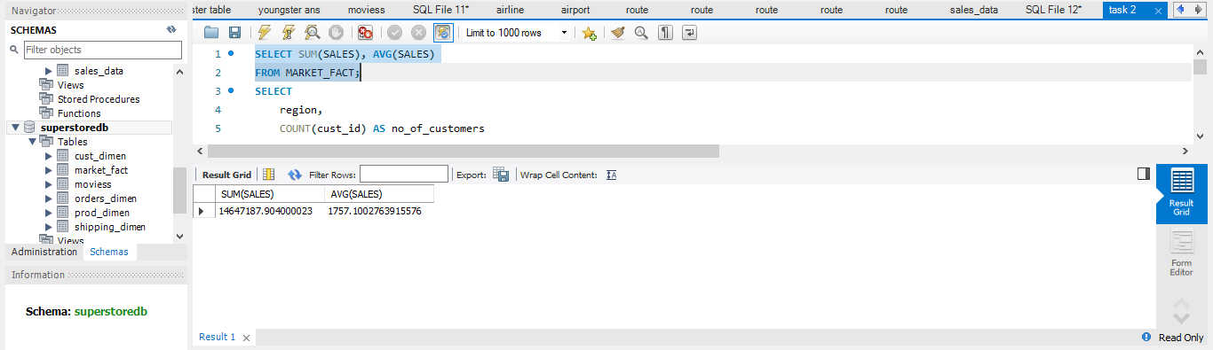

B. Display the number of customers in each region in decreasing order of
no_of_customers. The result should contain columns Region, no_of_customers

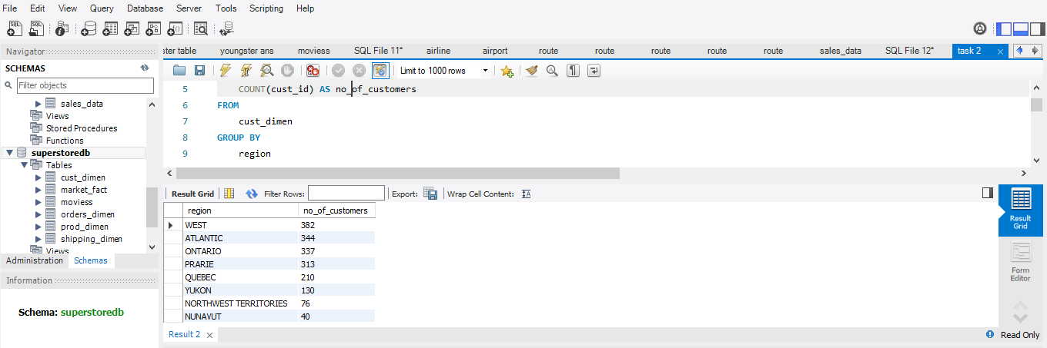
C.Find the region having maximum customers (display the region name and max(no_of_customers)

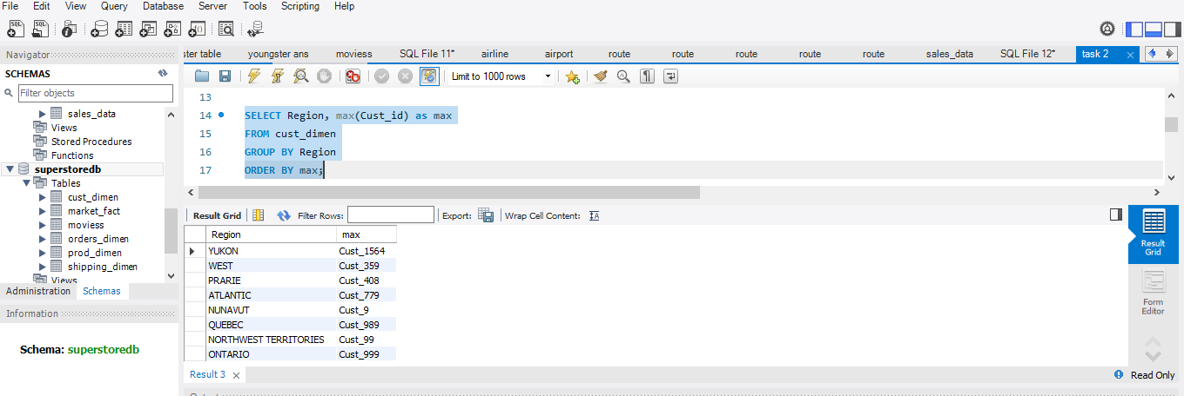
D. Find the number and id of products sold in decreasing order of products sold (display product id, no_of_products sold).

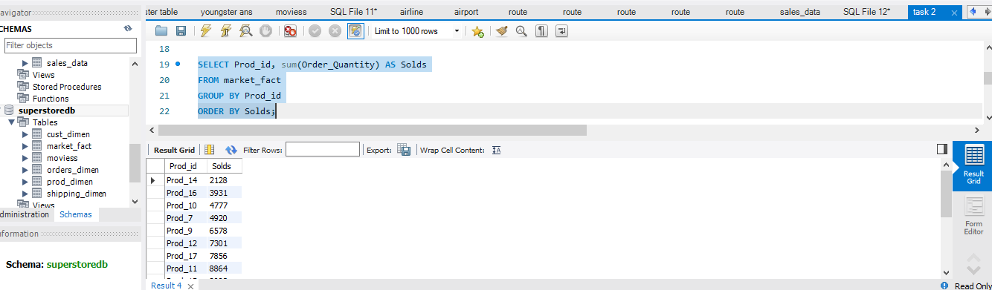
E. Display the product categories in descending order of profits (display the product category wise profits i.e. product_category, profits)?

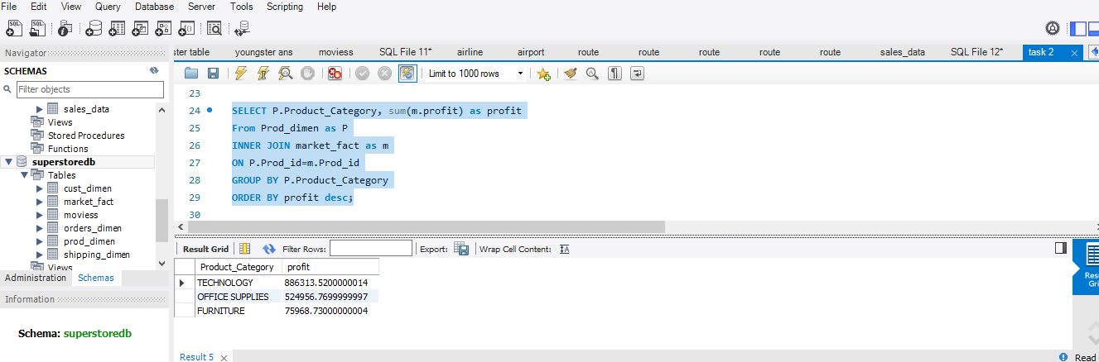
F. Display the product category, product sub-category and the profit within each sub category in three columns.

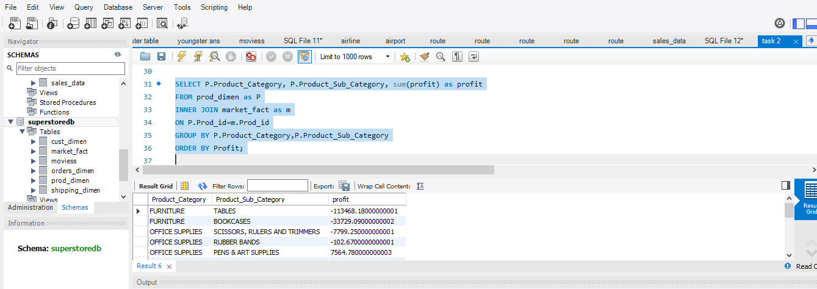

G. Find all the customers from Atlantic region who have ever purchased ‘TABLES’ and the number of tables purchased (display the customer name,no_of_tables purchased)

